**PROJECT TITLE : FLOOD MONITORING AND EARLY WARNING**

**PHASE 2 : INNOVATION**

**INTRODUCTION**

A flood monitoring system is highly relevant in today's world as climate change is causing an increase in the frequency and severity of floods. The system can provide critical information to communities, emergency responders, and urban planners, enabling them to prepare and respond effectively to floods. With the growing population and infrastructure development in flood-prone areas, the risk of loss of life and property damage from floods is increasing.

A flood monitoring system can help to mitigate these risks by providing real-time data on water levels, weather conditions, and other relevant parameters. By developing and implementing a flood monitoring system, we can enhance disaster management, reduce the impact of floods, and help communities to adapt to the challenges posed by climate change. This flood monitoring system is intended and created to promptly warn and alert authorities about the flood.

A flood monitoring system is an essential tool for minimizing the loss of life and property damage caused by floods. It provides real-time data on water levels and weather conditions, which enables early warnings and effective emergency response. A flood monitoring system can also inform urban planning and infrastructure development in flood-prone areas.

Raspberry Pi is utilized as a sensing device for measuring water level and other environmental parameters. The system architecture consists of a Raspberry Pi board, a water level sensor, a temperature and humidity sensor.

For detecting the rise in water level Ultrasonic Sensor and Water Level Sensor is used. For detecting the change in humidity and temperature Humidity and Temperature Sensor is used. The data from the DTH11 and HC-SR04 is read by the microcomputer and analyze the data in order to detect the level of water. If the level of water is less than the defined threshold value then the microcomputer turns the LED and buzzer on.

Furthermore, the data obtained from the microcomputer is uploaded to the database. The values of the sensors updating in real time can be monitored in database table. The content of the database table is now linked with the web API (Application Programming Interface) and trigger is set.

### **Raspberry Pi**

The raspberry Pi used is the brain of the project. It is responsible for acquiring, processing, storing and communicating the information from sensors, and then executing the events respectively. .

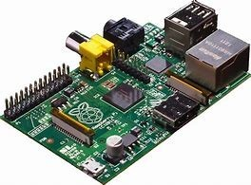

Raspberry reads the data from the Ultrasonic sensor (HCSR04) and Temperature and Humidity sensor (DHT11). Then the Raspberry pi processes the obtained value of the sensor and displays it

### **Ultrasonic Sensor**

The sensor head emits an ultrasonic wave and receives the wave reflected

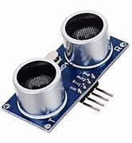

back from the target. Ultrasonic Sensors measure the distance to the target by measuring the time between the emission and reception. It uses a single ultrasonic element for both emission and reception. In a reflective model ultrasonic sensor, a single oscillator emits and receives ultrasonic waves alternately. This enables miniaturization of the sensor head.

### **Buzzer**

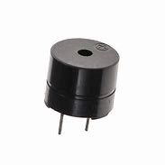

A buzzer is a device which makes a buzzing or beeping noise. This type of buzzer requires some kind of oscillator to drive it—if you apply a DC voltage you will just get a click. They are used in places where you need something that emits an audible tone, but don’t care about high-fidelity sound reproduction.

### **Temperature and Humidity Sensors (DHT11)**

Temperature sensors measure air temperature, while humidity sensors measure air humidity. The calculation of the air humidity does not directly influence a wind site assessment, but knowing this parameter helps assessing the potential danger of ice build-up at the measuring location.

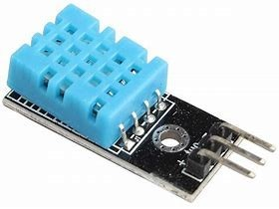

Temperature sensors should always be mounted at a height of at least 10m to ensure sufficient distance from heat radiating from the earth. This DHT11 Temperature and Humidity Sensor features a calibrated digital signal output with the temperature and humidity sensor capability. It is integrated with a high-performance 8-bit microcontroller.

**LED**

LEDs (Light Emitting Diodes) can be used in a flood monitoring system in various ways to provide visual indicators and status notifications.

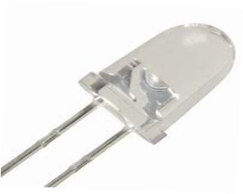

**BLOCK DIAGRAM**

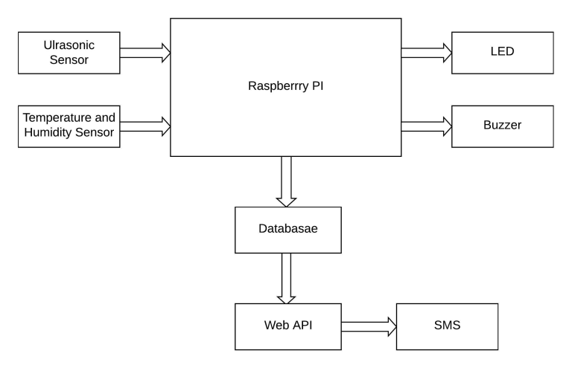

Raspberry reads the data from the Ultrasonic sensor (HCSR04) and Temperature and Humidity sensor (DHT11). The certain threshold value for the distance between the ultrasonic sensor and the river is fixed.The value of distance obtained from the ultrasonic sensor is updated repeatedly with the change in the water level. If the value of the distance is less than the fixed threshold value then the led and buzzer will turn on which signifies that there is high chances of occurring flood. If the value of distance is greater than the fixed threshold value then the LED and the buzzer will remain off which signifies that there is nothing to worry about.

The values obtained are uploaded to the local server of the Raspberry Pi using the MySQLdb. The values of temperature and the humidity changes corresponding to the changes in the environmental temperature and humidity and gets updated in the database table. The main role here is of the ultrasonic sensor. The value of the ultrasonic sensor is updated repeatedly in certain interval of time and shows the distance. If the value of the distance is less than the threshold value then the warning message regarding flood will be displayed in the remarks and if the value of the distance is greater than the threshold value then remarks will display default message. The data in the database table are updated automatically every 6 seconds.

Now, the main motive of the system to alert the people about the coming flood is done by the web API. The data from the database is linked to the web API. What the web API does is, it continuously keeps on reading the value of sensors from the data base. And when the value of distance becomes less than the threshold value the web API indicates it so by changing the color the trigger used there. The contact or phone number of the residents are also uploaded in the web API so, it quickly informs the local people about flood by sending the warning SMS to the people whose numbers are registered in it.

**IMPLEMENTATION**

## **DHT11 Sensor**

The DHT11 temperature and humidity sensor is a nice little module that provides digital temperature and humidity readings. 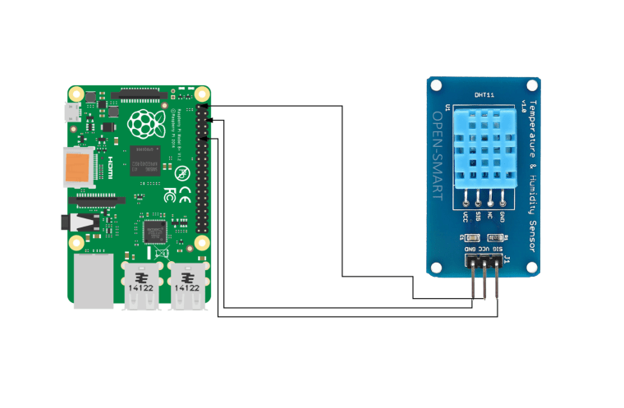

## **Buzzer**

A buzzer or beeper is an audio signaling device, which may be mechanical, electromechanical, or piezoelectric (piezo for short). 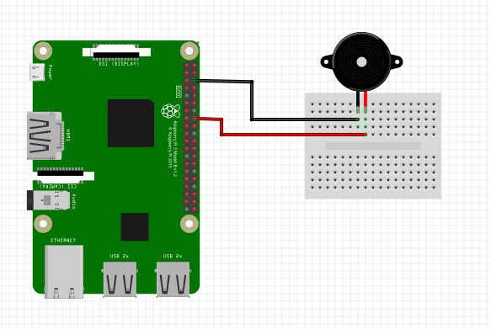

## **LED**

The circuit consists of a power supply (the Raspberry Pi), an LED that lights when the power is applied, and a resistor to limit the current that can flow through the circuit. using one of the ‘ground’ (GND) pins to act like the ‘negative’ or 0 volt ends of a battery. The ‘positive’ end of the battery will be provided by a GPIO pin. Here we will be using pin 18. When they are ‘taken high’, which means it outputs 3.3 volts, the LED will light.

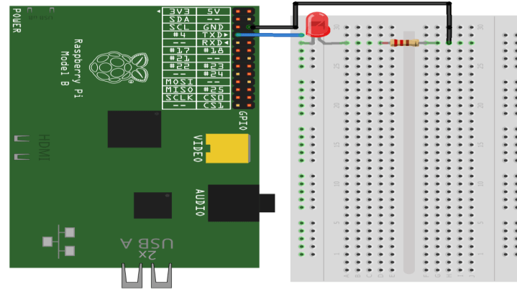

## **Ultrasonic sensor with pi**

There are four pins on the ultrasound module that are connected to the Raspberry .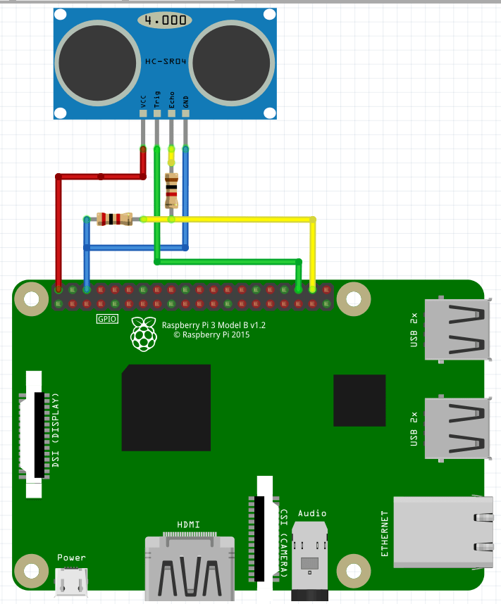

**CONCLUSION AND FUTURESCOPE**

Finally, it is concluded that, the system can detect and hypothesize the flood earlier. The project is based on embedded system and close loop control system. System consists of hardware and software applications to detect water level of rivers, dams etc. System automatically detects the change in level of water and alerts the system when it crosses the threshold value. The system include ultrasonic sensor to detect the rise in water level and alert.DHT11 sense the temperature and humidity which helpto analysis the environmental factor for flooding. If the water level crosses the threshold value than Raspberry pi turns the buzzer and led turn on which symbolizes the warning for early flood.